# Word2Vec Overview

## What is Word2Vec

What is Word2Vec? As the name suggests the process of converting words into their equivalent vector representations is called word2vec.

## How is it done

When we think of a vector in a vector space we know by definition that vector is a quantity which has both magnitude and direction.

During our high school days we have learnt operations on 3 Dimensional vectors V = ai + bj + ck. Where i, j, k denote unit vectors in X, Y and Z planes respectively. a, b, and c denotes the magnitudes of components of V in the respective directions

The below diagram is recollecting the vector topics.

x

y

z



$$\vec{V}$$

a

In programming languages these and often in mathematics also these vectors $\vec{V}$ is represented as a single dimensional matrix containing d columns (where d = dimension, in our case = 3) or simply a list of 3 elements.

V = [a, b, c] where a, b, c ∈ ℝ.

So what does word2vec perform is by a mathematical computation it projects a word into a fixed dimensional vector space.

## Steps to perform this

1. To understand let’s consider the example of a financial statement. **Non performing assets are one of the problems turning into banking crises as it leads to loss.**
2. Now we want to calculate given the word **banking** what is the probability of the word immediate to the right of banking is crises, then probability of the next one to be as, the probability of the immediate left to be into etc. This method is called the skip-gram method.

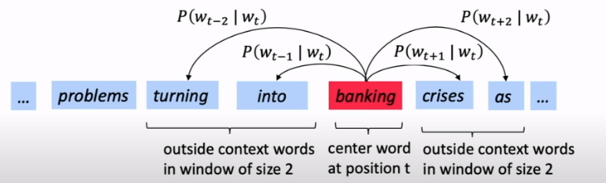

**Wt-2**

**Wt-1**

**Wt**

**Wt+1**

**Wt+2**

**Wt+T**

**Wt-3**

**Wt-T**

1. To visualize the outcome let’s do the following:
   1. Create and tokenize the above sentence as below. 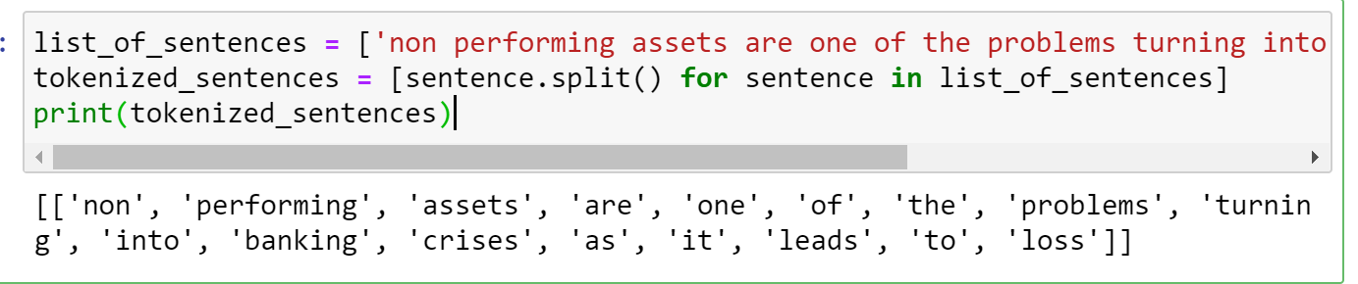
   2. We take context window of fixed size T=5
   3. Project the word vector into 2 Dimensional space using the above mentioned skip-gram method. 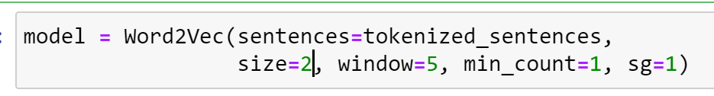
   4. Get the value of the word vectors 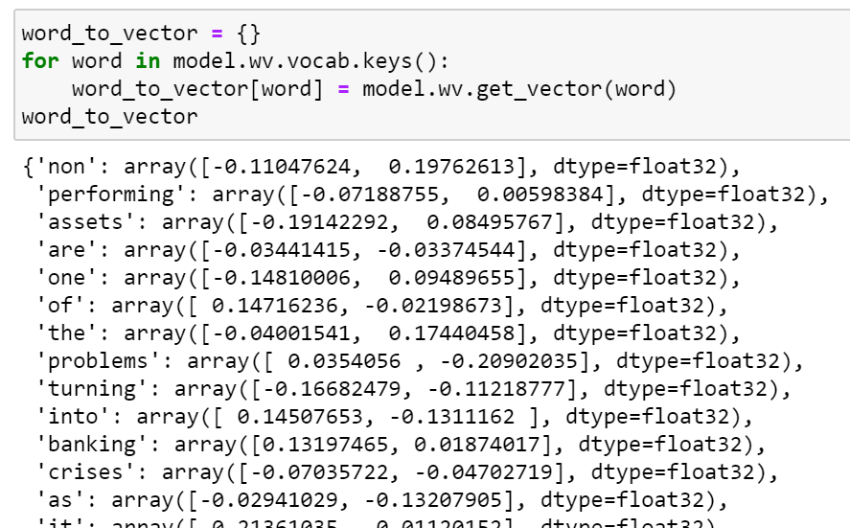
   5. Visualize the word vectors in 2D space. 